Food-Industry Relative Valuation (R)
CPG / restaurant / agri snapshot → clean numerics → GODIVA outlier → 10-flag peer index → screen → 50/200-day MAs
Problem Statement
A cross-section of packaged-food, beverage, restaurant, grocery, protein, dairy, agribusiness and ingredients names arrives as a messy CSV (%, $, commas). The analyst must decide which food companies look cheap versus aisle-level peers, without treating a Swiss luxury-chocolate listing as “the confectionery market.” Live vendor URLs do not make a reproducible lab.
Solution Strategy
- Bundle data/foodviz.csv (~970 names) and data/food_historical_prices.csv.
- clean_numeric via gsub; apply after the six identifiers; make.names.
- Histogram raw vs Price<$150; sector bars; drill Confectionery → Luxury Chocolate → GODIVA ($18,750); drop and re-average.
- melt → mean → dcast sector and industry Price/PE/PEG/PS/PB; ten below-average flags; RelValIndex 0–10.
- US screen + food-cost knob + zoo rollmean overlays on HSY/GIS/TSN/ADM/MCD/SBUX.
Solution
Confectionery mean price is ~$339 with GODIVA and falls into the same mid-double-digit band as other food aisles once the luxury listing is removed. Most names cluster under $50 after capping the histogram. RelValIndex is a teaching count; raising the cutoff from 6 to 10 shrinks the passer list sharply. Extra food levers — Gross Margin and Food Cost % — belong in practice and simulation, not as silent substitutes for P/E.
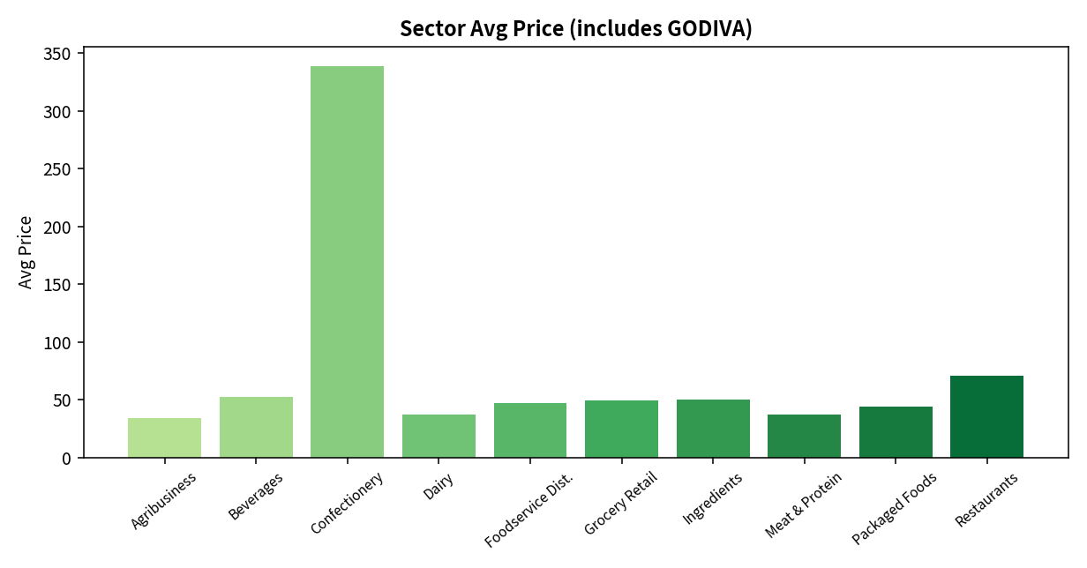
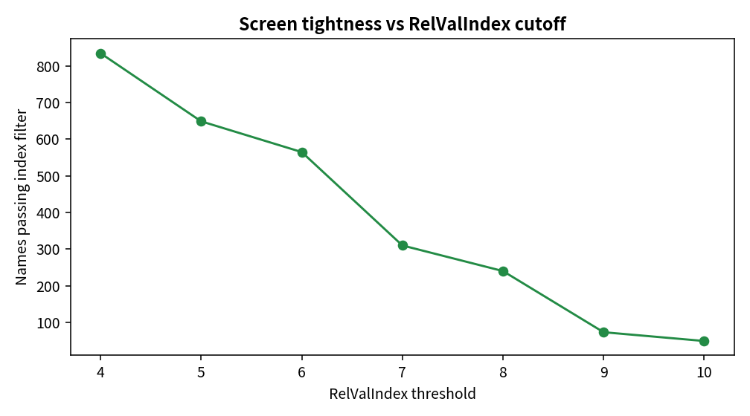
Key Takeaways
- Aisle-level means lie when one luxury or dual-class name sits in the average.
- Relative value compares cereal to cereal, not a farm to a cocoa DCF.
- Food Cost % and SSS are useful extras; they do not replace the 10-flag core.
- Screens shrink the list. MAs describe 2011–12 input-cost paths of survivors.
- Rewrite for CPG quant, category screener, CFO, and shopper before circulating.

